[1] CSA-1557 CLOUD COMPUTING LAB PRACTICALS

1.Demonstrate Infrastructure as a Service (IaaS) by creating a resources group using a Public Cloud Service Provider (Azure), configured with minimum CPU, RAM, and Storage.

Step-1:

Create a microsoft account with your saveetha mail id and sign in to azure for students and get $100 for free and open the microsoft azure.

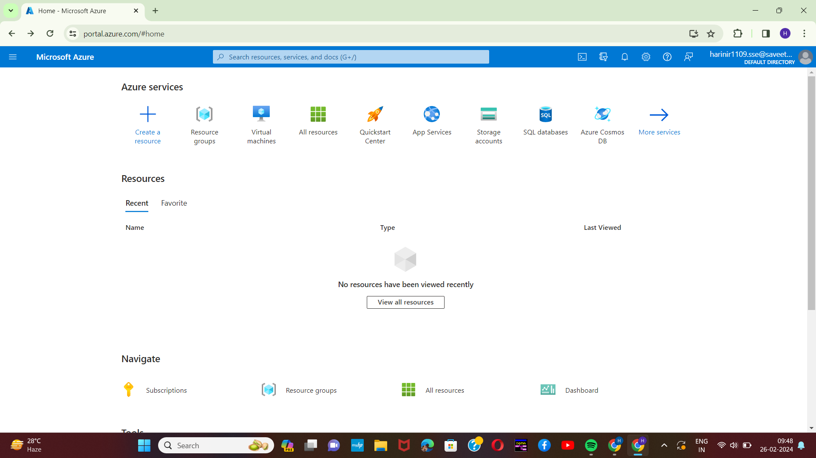

Step-2:

Next step is to click on the resource group which is shown at top.

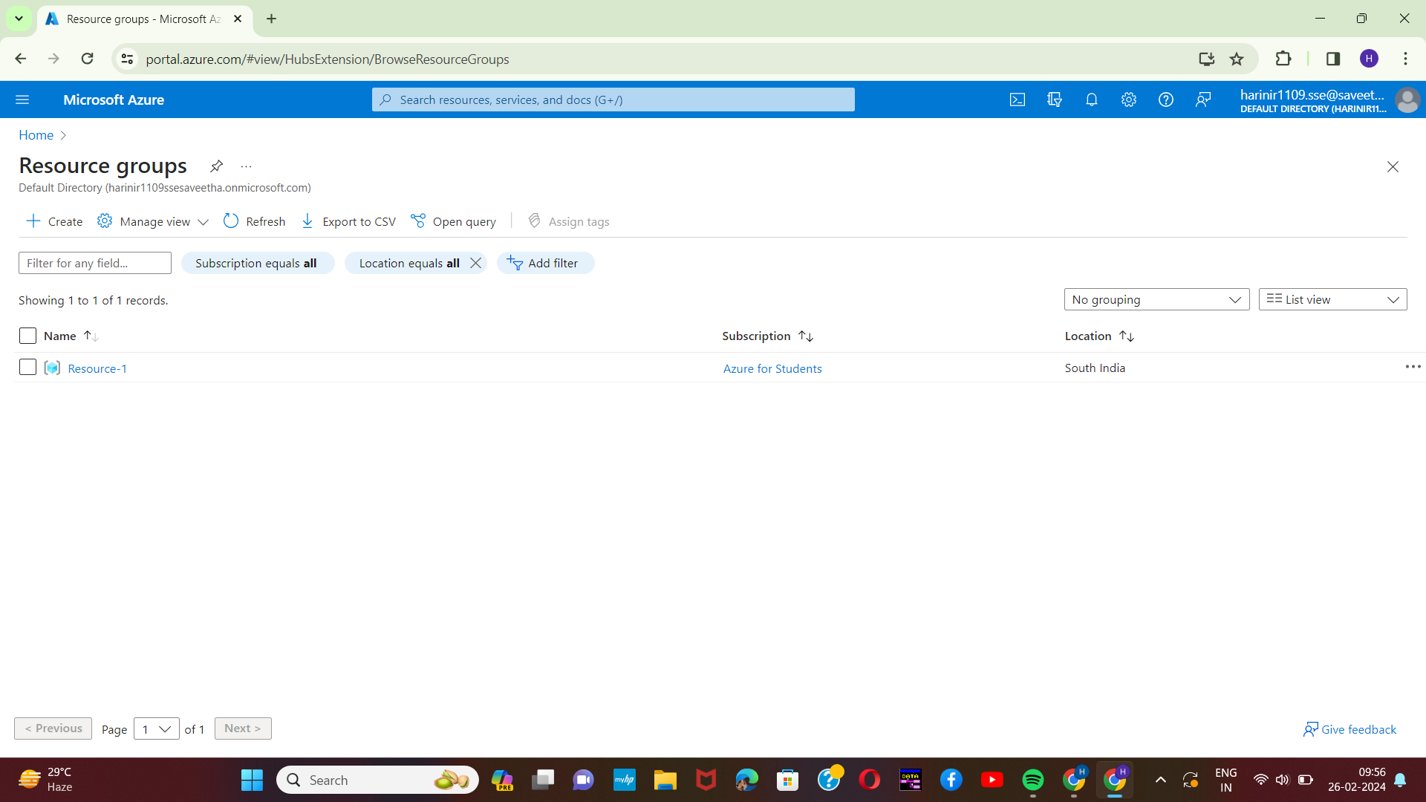[2]

Step-3:

Next step is to click on the create (+ symbol) to create a new resource group and create a name and region for the new resource group which is being created.

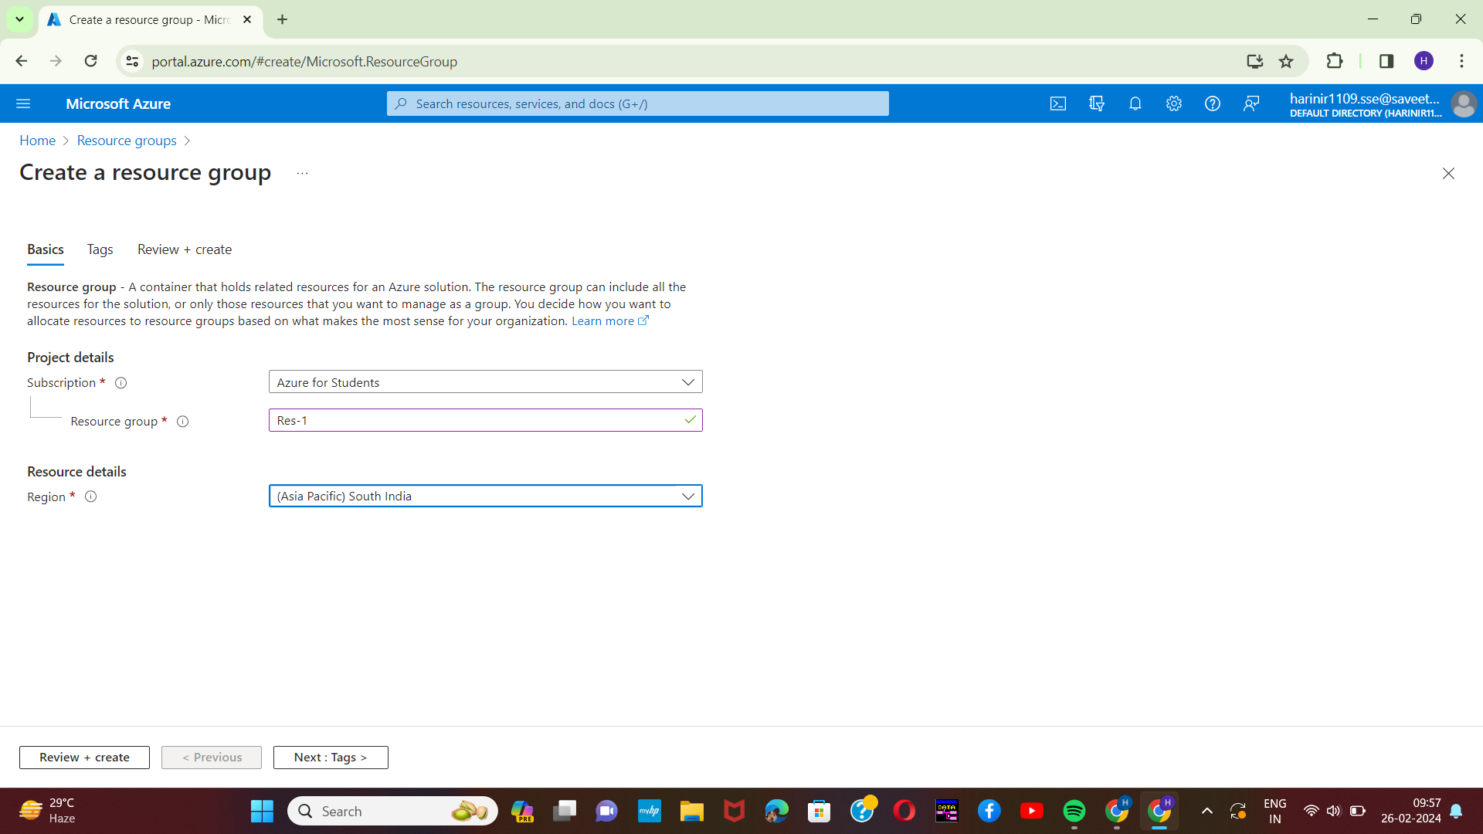

[3]Step-4:

Next step is to provide a name and the value for the resource group in the tags column.

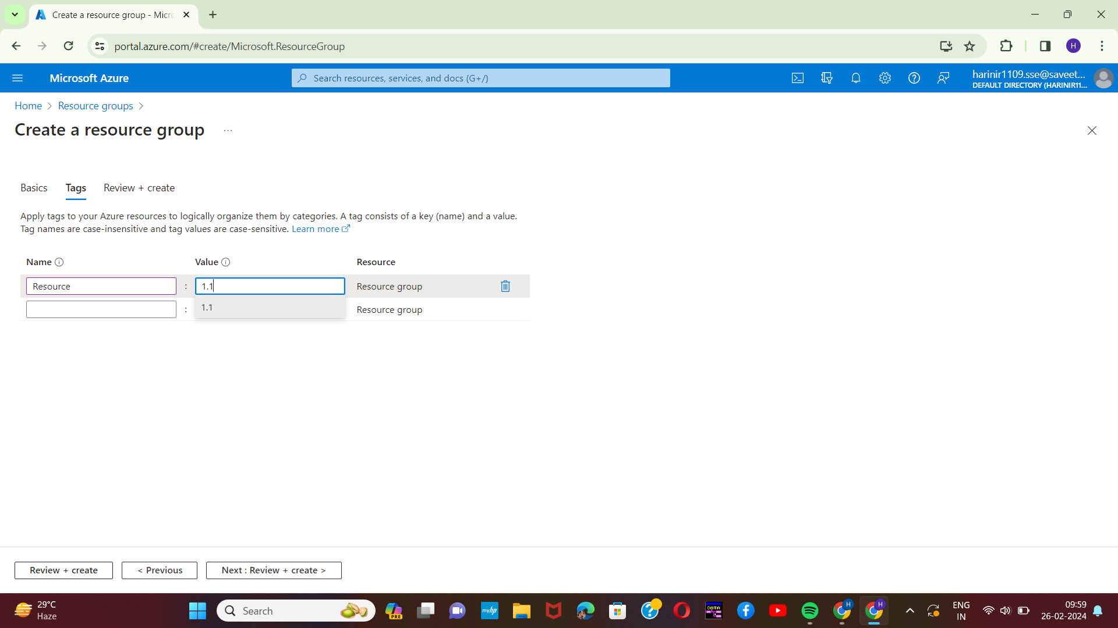

Step-5:

The next step is to review and create a new resource group and if it shows validation is passed the resource group has been created.

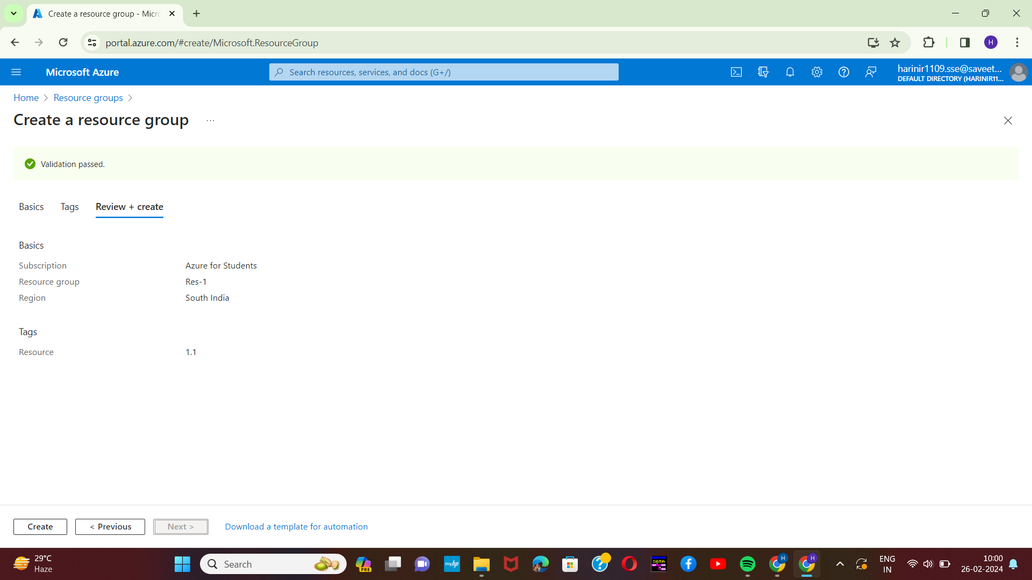[4]

Step-6:

Once the validation is passed click on the create button at the bottom left corner and the created resource will be shown at the dashboard.

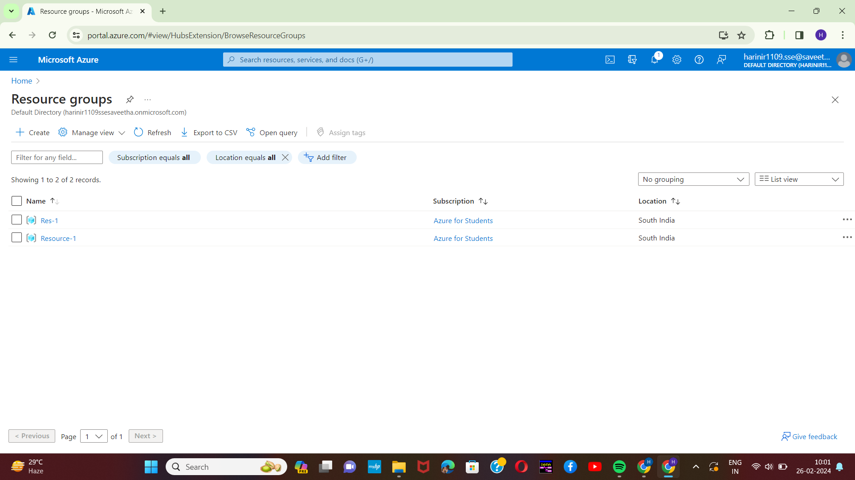

1. Harini 192221109
2.
3.
4.